**LDS Philanthropies Telefund**

**Interview Mock Call Information Sheet**

**How it Works**

Using the attached script, you will be asked to call the donor below and demonstrate basic calling skills and techniques. Once finished with the first call, **stay on the line** to receive feedback regarding your performance. Take a couple minutes to review the received feedback, and call again to repeat the process. After the second call, you may hang up as soon as you are finished. Afterwards, we will contact you to let you know if you have been selected for a final interview.

You will call **____________**at _____________________. If the line is busy, wait a few minutes and try again. Please keep trying until you get through to someone.

**Donor:**

**Taylor Johnson**

**6508 E. Odessa Street**

**Mesa, AZ 85215**

**Last gift $100 in 2017 to BYU Scholarships**

**What We Look For**

We are looking to measure your natural abilities in:

* Calling skills
* Applying feedback
* Inviting philanthropic giving
* Building sincere rapport

**Components of a successful call**

* **Introduction –** Introduce yourself, greet the donor, and state your purpose
* **Purpose –**Do all of the following: give an opportunity to donate, update donor info, and answer any questions.
* **Rapport –** Ask questions that encourage the donor to talk about their experience at BYU. For example, “What did you enjoy most about your experience at BYU?” or “Why did you originally choose to support BYU?”
* **Ask Structure –** Ask three times, specify an amount and designation (in this case BYU Scholarships)
* **Ask Effectiveness –** All asks should be concise and direct. Give the donor a reason to donate in as few words as possible. i.e. “Can we count on you to make a contribution of _(amount)_ to _(designation)_ this year?”
* **Empathy & Sincerity –** Be understanding if the donor refuses. **Validate the donor’s concerns** and modify your approach according to the needs of the donor
* **Tone –** Be enthusiastic and friendly over the phone. Regardless of how the donor reacts, remain positive.
* **Professionalism –** Avoid unprofessional or filler words (“awesome”, “um”, etc.). Keep an even tone and moderate voice speed.
* **Objection Handling –** Work with the donor not against them. Help the donor have an opportunity to give regardless of their circumstance.
* **Feedback Application –** When receiving feedback try to ask clarifying questions and then make an effort to apply all pieces of feedback.

**The Call Structure**

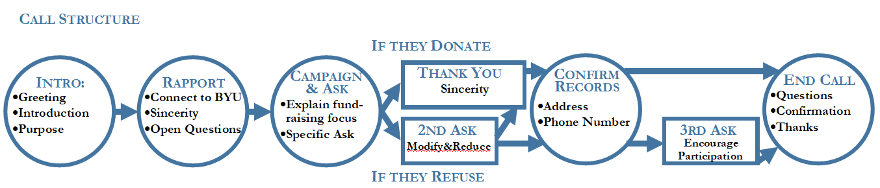



**Telefund Script**

**Purpose of Call**

You are calling the donor to 1) give them the opportunity to donate to BYU, 2) update our university records, and 3) answer any questions they may have about BYU.

**introduction**

When beginning the call, remember to warmly introduce yourself, explain that you are calling from BYU for the purposes listed above.

**Rapport**

After introducing yourself, ask a few open ended rapport questions. The whole point is to make a connection: ask them about their experience at BYU, share information about yourself you feel would be appropriate, ask if they have any questions about the campus today, etc.

**Campaign**

Take time to understand the philanthropic interests of the donor. Review their education background.

Focus your asks on their interests. An example could be, “What did you study? What was your favorite part? Would you like to give back to that program?”

**ASKS 1 & 2**

Invite the donor to double their last donation. If they cannot do this, see if they would be willing to donate 1.5x their last donation (e.g. $150). Be prepared for a no, but don’t give up. Remember to be empathetic towards their situation.

**Update Records**

Updating their records can be used as a buffer/transition between asks. Verify their address, email, and phone number.

**3rd ASK**

If the donor has refused your first two asks, invite them to match their last donation to help support the students at BYU.

**If He/She Pledges**

Express gratitude and inform them that they should be receiving a pledge form within about a week. Ask for any remaining questions, thank them for their time, and end the call.

**If He/She Doesn’t Pledge**

Inform the donor that if they feel that they can give in the future, they can do so on our website, giving.byu.edu. Ask if they have any questions about BYU that we can help them with, thank them for their time, and end the call.

**Final Notes:**

* Making a connetion with the donor is important. Don’t be afraid to take a few minutes to have a good conversation with them when you are buidling rapport.
* All calls vary in length, so a successful call will not have a definite time line. Do not feel pressured to talk for a certain amount of time or to rush the call. Just be sure you have addressed every aspect of the call.